CmpE 110 LAB4 Dr. Ahmet Bindal

Part 1: Design a voltage sensor amplifier with an amplification of -10

Determine R1 and R2 in the following operational amplifier circuit such that the amplification is -10. Assume the input voltage is sinusoidal at 1KHz and its value is 0.1V peak-to-peak. Use LM324 operational amplifier from the LTSPICE digital library with +5V and -5V power supplies.

After measuring the voltage gain, explain the inconsistencies between the measured value and the theory if there is any.

Increase the frequency to 10KHz, 100KHz and 1MHz and measure the gain in each case. Record the drop in amplification and explain the reason behind the drop.
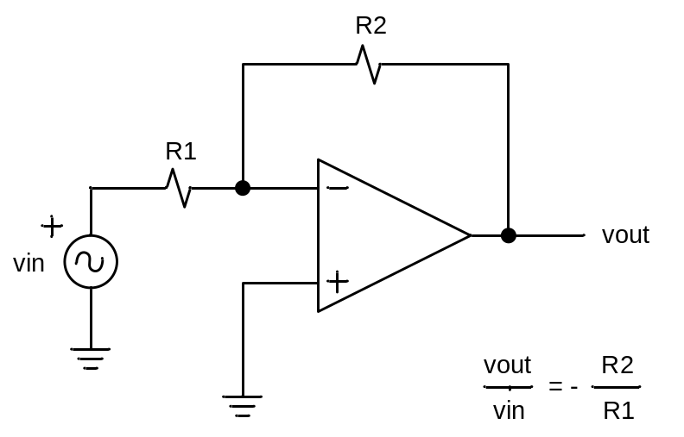

Now, swap the connections at the input (input goes to “+” terminal and ground goes to “-“ terminal).

Are you getting vout / vin = R2 / R1 = +10 or something else? Explain the results.

Part 2: Design voltage sensor amplifier with an amplification of +10

Design the following operational amplifier circuit such that the amplification is +10. Assume the input voltage is sinusoidal at 1KHz and its value is 0.1V peak to peak. Use LM324 operational amplifier from the LTSPICE digital library with +5V and -5V power supplies.

After measuring the voltage gain, explain the inconsistencies between the measured value and the theory if there is any.

Increase the frequency to 10KHz, 100KHz and 1MHz and measure the gain in each case. Record the drop in amplification and explain the reason behind this drop.
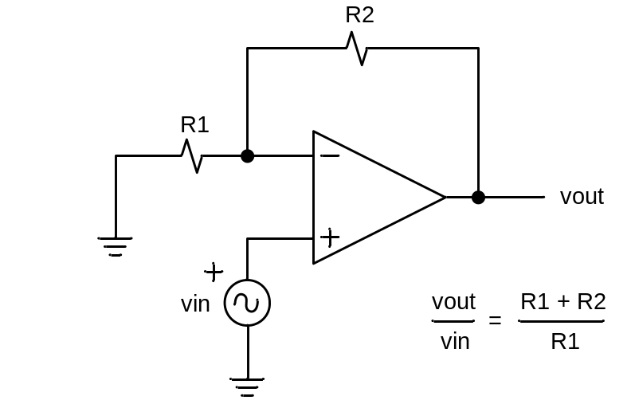

Swap the connections at the input (input goes to “-” terminal and R1-R2 connection ground goes to “+“ terminal).

Are you getting vout / vin = (R1 + R2) / R1 = -10 or some other value? Explain the results.

Part 3: Design input/output isolation circuit with unity gain

Measure the output voltage when you change the input peak-to-peak voltage 0.5V, 1V and 2V oscillating at 1KHz. Explain the inconsistencies between the experiment and the theory if there is any.

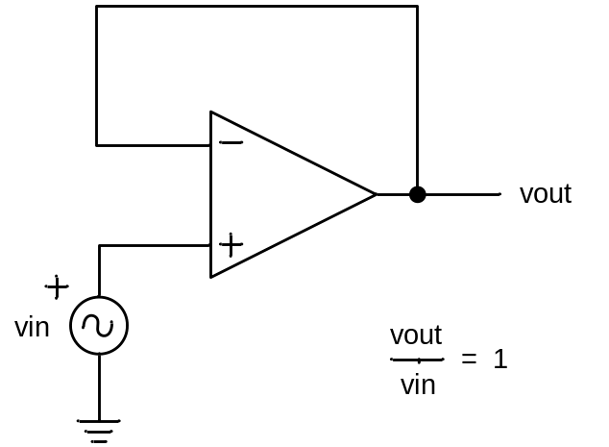
Part 4: Design a voltage sensor amplifier with signal and reference inputs

Use vsig (mimicking a sensor) and vref (reference) in the opamp circuit below. Calculate the values of R1, R2, R3 and R4 to produce vout = - (vsig – vref). Re-compute the resistor values to obtain vout = -10 (vsig – vref).

Assuming vout = -10 (vsig – vref), vsig is a 1V peak-to-peak sinusoidal voltage, and vref = 0.75vsig all operating at 1KHz, find R1, R2, R3, R4, RA and RB. Repeat the same experiment with vref = 0.5vsig and vref = 0.25vsig. Tabulate your experimental and theoretical results at the output in an Excel sheet.
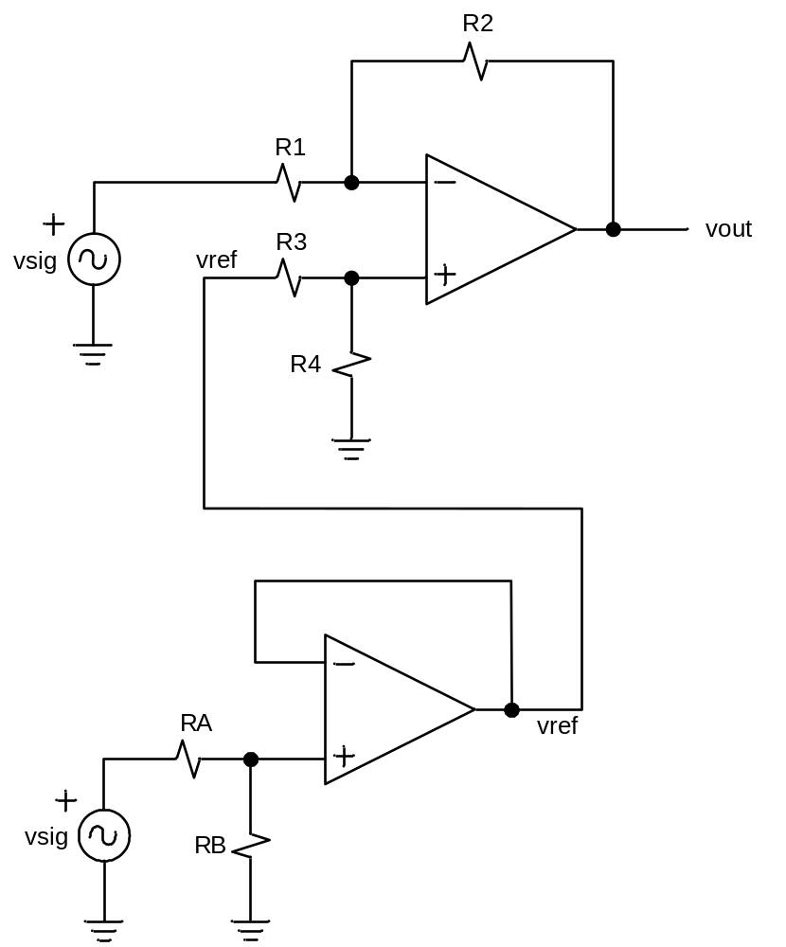

Part 5: Design a summation amplifier with 2 sensor inputs

Apply vin1 = 1V peak-to-peak and vin2 = vin1, both operating at 1KHz, to the circuit below. Select the value for R, and record the output.

Now, produce an AC voltage source for vin2 by using the circuit in the previous experiment that generated vref. Adjust the values of RA and RB in the “vref” circuit in order to obtain:
(i) vin2 = 0.75vin1
(ii) vin2 = 0.5vin1
(iii) vin2 = 0.25vin1
The purpose of this exercise is to be able to add different values of vin1 and vin2 together. In each case, select the value of R, and record the output voltage level from the experiment.

For each of four experiments above, explain the inconsistencies between the experimental and the theoretical output voltage levels if any.

